Stem cells: what happened to the radical breakthroughs?
Much was promised in the late 1990s, but the challenge of advances such as growing whole human organs has been difficult to deliver
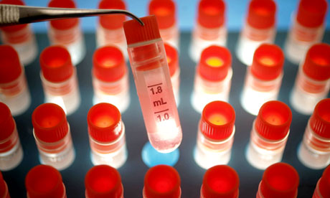

It's 1998 and science is taking big strides. The first cloned mammal, Dolly the Sheep, has just had her first lamb; the first robotically assisted heart surgery has been completed; Furbys have hit the shelves. In a boldannouncement, biomedical engineer Professor Michael Sefton declared that within 10 years, scientists would have grown an entire heart, fit for transplant. "We're shooting big," he said. "Our vision is that we'll be able to pop out a damaged heart and replace it as easily as you would replace a carburettor in a car."
Stem cells were a little-known area of research then, but one gathering pace. Here was a blank-template cell with the potential, given the know-how, to become any other type of cell in the body. The year before, in 1997, the first regenerative cell-therapy had been given the go ahead, where stem cells were used to regrow cartilage in the knee. Later in 1998, the first human embryonic stem cells were isolated. Sefton's forecast seemed justified.
Fifteen years on, however, we've had some liver cells, eye cells, even alab-grown burger, but no whole human organs. We could be forgiven for asking: where's our heart? It does seem strange that a field stoking so much excitement could be so far off the mark. Speaking last week about the vision that he and his colleagues outlined in 1998, Sefton said they had been "hopelessly naive". As time plodded on and an understanding of the biological complexity increased, the task seemed bigger and bigger. Even now, a cacophony of headlines later, we are not much further ahead.
Chris Mason is a professor of regenerative medicine at University College London and believes that concentrating on organ regeneration is missing a trick. "These organs are immensely complex," he said. "They've got nerves, blood vessels, in the case of the liver, a bile system – there are huge degrees of complexity. These things take a long time to grow in humans, let alone in the lab without all the natural cues that occur in the growing embryo.
"The research community is still going towards trying to produce major breakthroughs, but if you do the economics, you have to move forward things that are actually doable. There's no good in coming up with a therapy that can't be afforded."
The real progress, he thinks, is seen through the doors stem cell research has opened. "People like words 'stem cells', but it's a pretty meaningless term in many ways. I think what we're really looking at is a technology that uses living cells as therapies," he said.
Recent studies have shown how stem cells can be used to mitigate the damage suffered by heart-attack patients. Cells were taken from another part of the body, induced into a stem cell state, and then placed around damaged heart muscle. Normally, the immune system responds to the heart attack so aggressively that it damages a lot of the muscle itself, but stem cells seem to dampen this response.
It's a role that could be exploited in treatment of acute stroke sufferers and those with Crohn's disease, where the body's own immune system attacks its tissue.
Another study suggests stem cells could be used to prevent blindness. While some are still in the clinical trial period, other cell-based therapies have now been used to treat more than one million patients. Why wait for complete heart failure and replace it with a whole, bioengineered heart, when you can use stem cells to stop failure in the first place?
But meanwhile, the pursuit of whole-organ generation continues. Last month, Japanese scientists used stem cells to grow functional liver cellsand transplanted them successfully into mice. "That's been exciting," Mason said. "But it'll be 10 or 15 years before you see that as something that people can go into hospital and have as a routine procedure. There's a lot of hard work to do to get that science actually into something that is effective for patients and affordable for the NHS."
There's a tension in medical research between the glory of the big discovery and the assiduous commitment to real application. "We're hoping the scope and possibilities of this project will catch the public's imagination," Sefton concluded in 1998. It did, but perhaps the public's imagination isn't always what science should be vying for.

